**Lesson 9 Demo 1**

**Setting up Poll SCM configuration Jenkins**

**Objective:** Configure a Freestyle Jenkins job implement Poll SCM build trigger in Jenkins.

**Tools required:** Jenkins

**Pre-requisites:** You need to have a Jenkins up and running.

Steps to be followed:

1. Log in to Jenkins CI tool and configure freestyle job to trigger build using Poll SCM trigger.

**Step 1: Log in to Jenkins CI tool and configure freestyle job to trigger build using Poll SCM trigger.**

1. Login to Jenkins CI tool with admin user and click on New Item to create new Jenkins’s job.

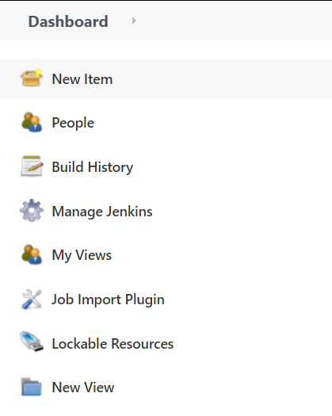

1. Select Freestyle project while creating Jenkins’s job and provide custom job name.

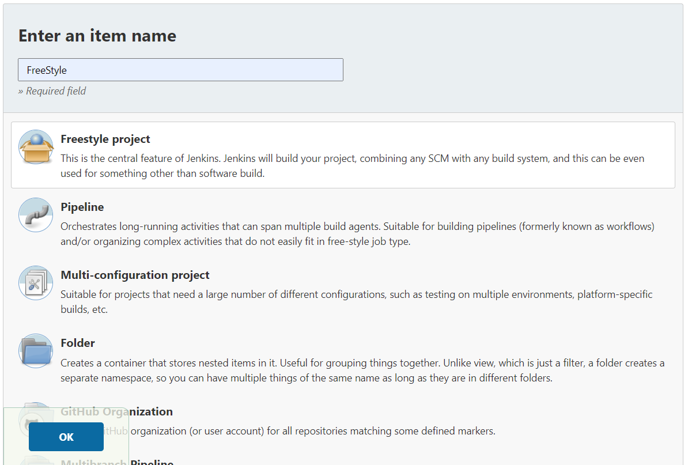

1. Once job name is provided, click on Ok button to save Jenkins’s job and a new configuration screen would be opened.

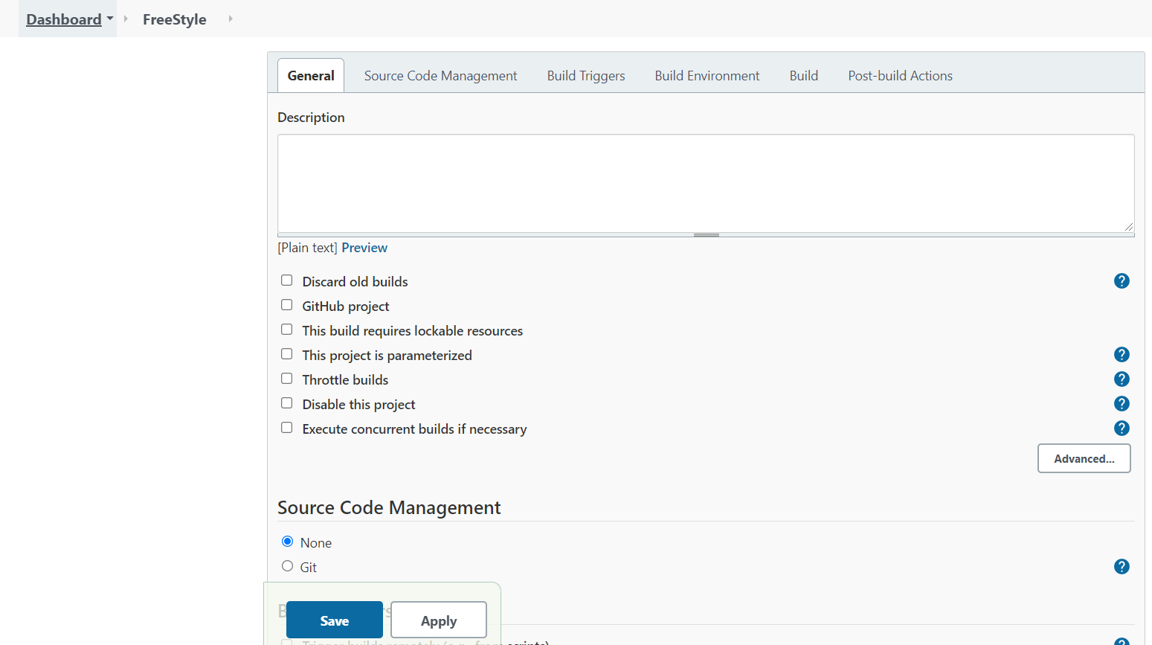

1. In configure screen you need to access Source Code Management tab to provide Git repository configurations.

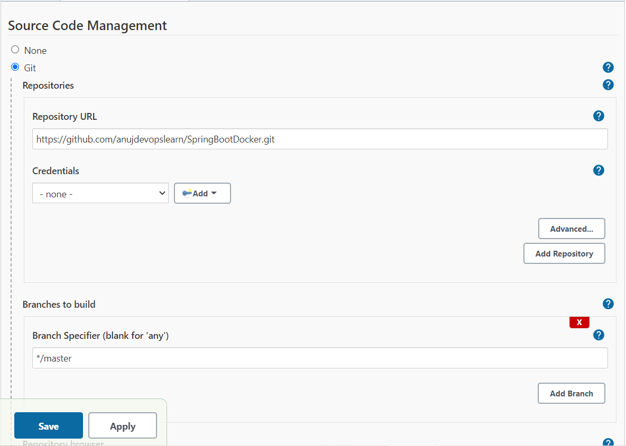

1. Once Git repositories configurations are configured in Jenkins’s job, you can configure Build Triggers so that you don’t have to trigger Jenkins’s job manually.

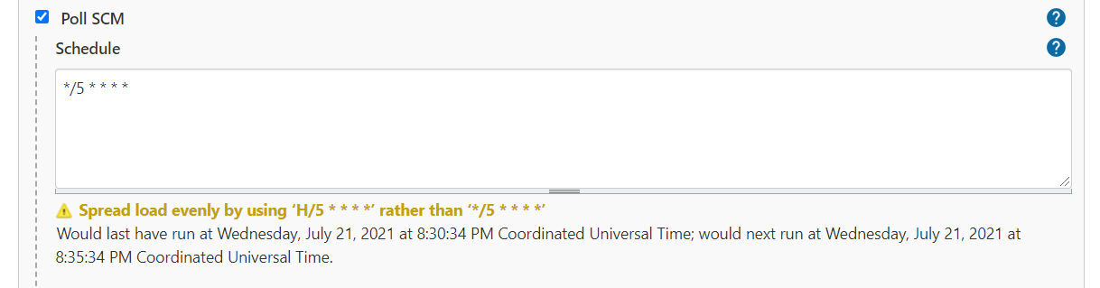

1. Once this is configured all you need to do is to commit new changes in Git repository. Jenkins will do polling to version control system depending on cron pattern provided in Poll SCM option.